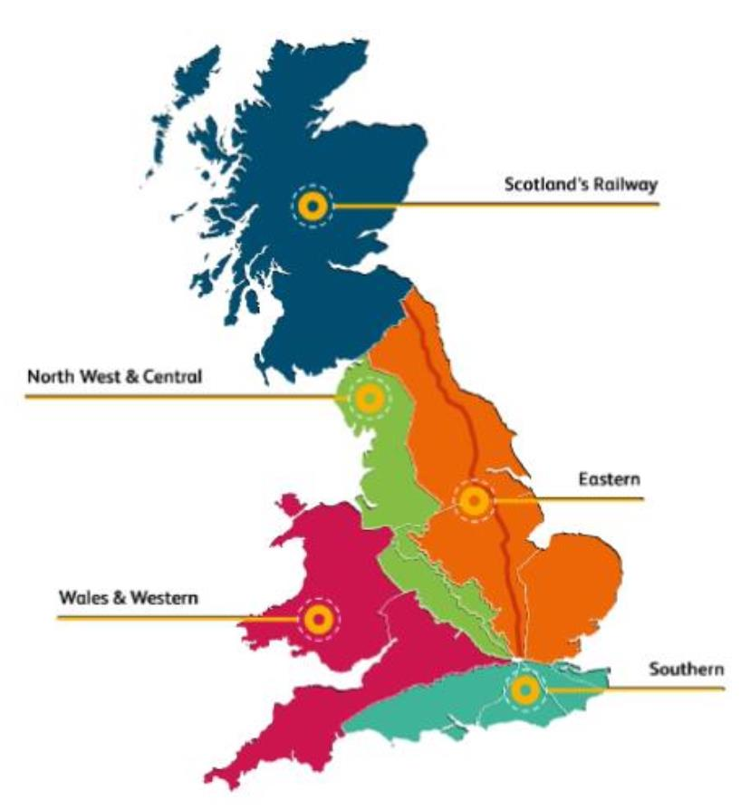
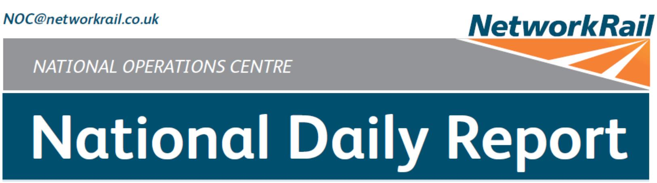

DATE OF REPORT: 6th July 2019
NOC MANAGER 0700 – 1900: Paul Dellow
NOC MANAGER 1900 – 0700: David Burnett
DUTY CONTROLLER 0630 – 1830: Lucinda Wing
DUTY CONTROLLER 1830 – 0630: Mark Elkin
SUPPORT CONTROLLER 0630 – 1830: Peter Ure
LONDON CONTROLLER 0700 – 1900: Martin Dineen
LONDON CONTROLLER 1900 – 0700: David Newton


TABLE OF CONTENTS
WRONG SIDE FAILURE REPORTS 3
SIGNALS PASSED AT RED (CATEGORY ‘A’) 3
DERAILMENTS 3
COLLISIONS 3
TRAIN OR VEHICLE RUNAWAY 3
OPERATIONAL INCIDENTS 3
STRANDED TRAINS 4
SIGNIFICANT POSSESSION PROBLEMS 4
FATALITIES 4
INJURIES/ASSAULTS 4
NEAR MISSES 5
RAILWAY CRIME 5
STATION OVERRUNS 5
BROKEN RAILS/TRACK DEFECTS 5
POWER FAILURES 5
POINTS FAILURES 5
SIGNALS/SIGNALLING SYSTEMS FAILURES 6
TRACK CIRCUIT & AXLE COUNTER FAILURES 6
BRIDGE STRIKES 6
ROAD VEHICLE INCURSIONS (NON-LEVEL CROSSINGS) 6
TRACTION FAILURES 6
WEATHER-RELATED PROBLEMS 7
FIRES 8
WILD REPORTS & HABD ACTIVATIONS 9
GROUP STANDARDS GE/RT8250 & GO/RT3350 9
MISCELLANEOUS 9
REVIEW TABLE 10
REAL TIME PERFORMANCE FIGURES 11
2

01 WRONG SIDE FAILURE REPORTS
Southern (Wessex) – CCIL 1976952
At 1445 the driver of 2R50, South Western Railway, 1350 Salisbury - Romsey, formed by unit 158883,
reported an AWS Fault Code 7, nothing received at a warning, at the TSR warning board on the Up line
at Southampton Airport Parkway. This was the same location as a similar fault yesterday (05/07/19), CCIL
1976398 refers. The magnet was replaced and normal signalling was authorised at 1639.
TRUST 131183 IQCZ
Cancelled 0 Part Cancelled 0 Trains Delayed 9 Minutes 134
02 SIGNALS PASSED AT RED (CATEGORY ‘A’)
Wales and Western (Wales) – CCIL 1976976
At 1425, 5S40, Transport for Wales, 1422 Shrewsbury – Shrewsbury Abbey Foregate Sidings, passed a
Stop Board on the Entrance Road at Abbey Foregate by 150 yards and entered Abbey Foregate Yard
without authority, coming to a stand clear within the yard. When questioned, the driver stated that they had
obtained authority from the Abbey Foregate signaller (group 5 cause). The signaller was questioned and
stated that they were unaware of the incident. The process for entering the yard involves the signaller at
Abbey Foregate clearing AF42 ground signal for the train to proceed as far as the stop board, before the
driver obtains permission from the designated person to enter the yard. It was confirmed that there was a
designated person on duty at the time of the incident. A Mobile Operations Manager was dispatched to
carry out requisite SPAD checks. The driver had already left duty prior to the incident being reported.
Arrangements were made for voice communications to be interrogated and an investigation to commence.
Southern (Wessex) - CCIL 1977071
At 1855 5B45, South Western Railway, 1830 Northam Depot – Poole Sidings, passed E763 signal on the
Arrival Road at Millbrook at red by three metres. When questioned, the driver stated they had been looking
at a 20 mph ESR, and then viewed E765 signal on the adjacent Down Main line in error (group 3 cause).
After consultation with South Western Railway, the driver was judged fit to continue, and after changing
ends was met on arrival back at Southampton Central at 1925.
03 DERAILMENTS
None.
04 COLLISIONS
None.
05 TRAIN OR VEHICLE RUNAWAY
None.
06 OPERATIONAL INCIDENTS
None.

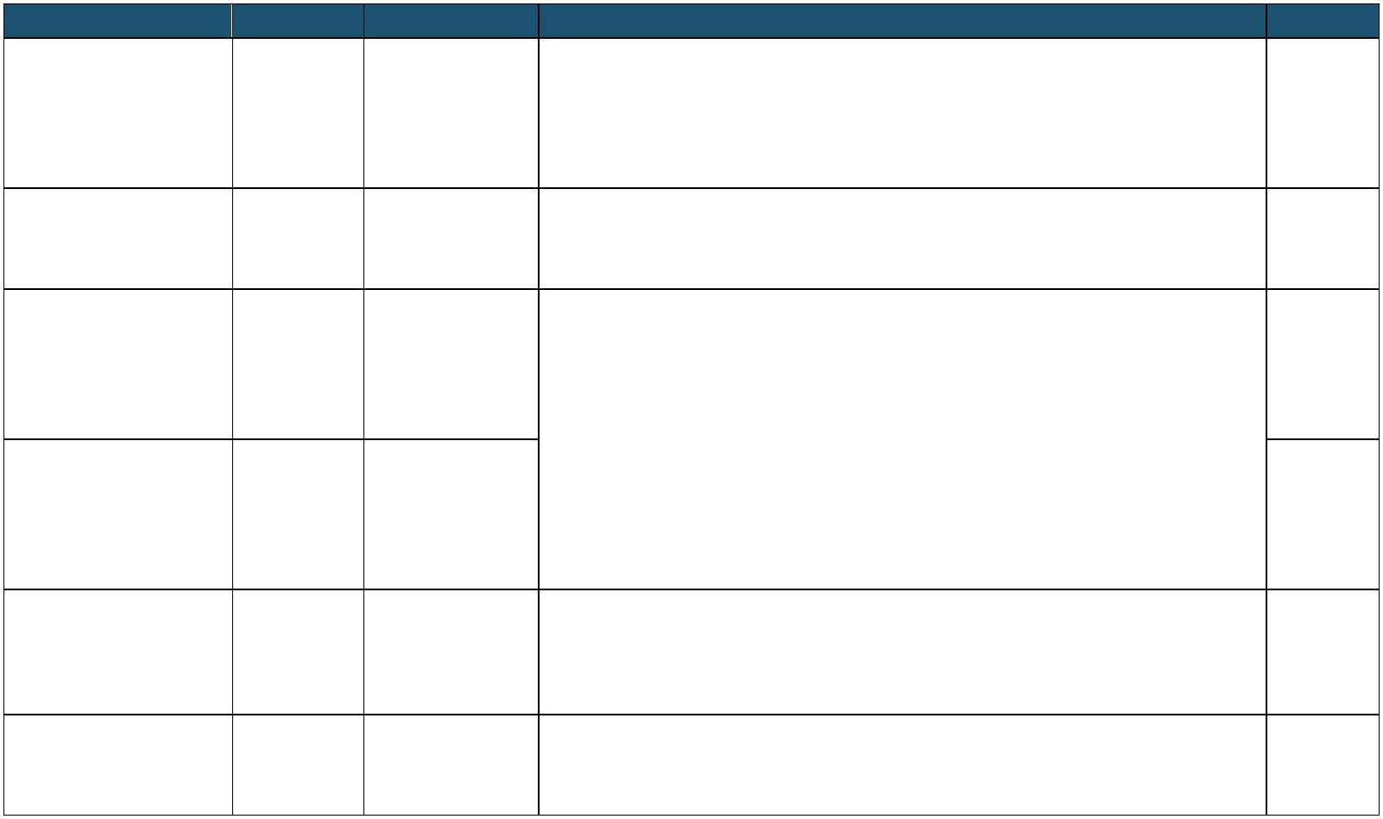
07 TRAINS WITH STRANDED PASSENGERS
TRAIN SINCE BETWEEN OUTCOME CCIL
Train came to a stand with VCB issues, reboot carried out with 2H08, Greater Temple Mills assistance from Bombardier Fleet Support but declared a failure at 0845.
Anglia, 0718 London 0729 – East Junction 20-30 passengers on board, including elderly passengers with luggage.
1976753
Liverpool Street – 0854 and Lea Decision taken to transfer onto an assisting unit and take passengers to
Cambridge North Bridge Stratford. Evacuation completed by 0921 and passengers detrained at
Stratford by 0940.
1D04, London North
Newark
Eastern Railway, 0900 - Train suffered activation of passenger emergency communication
Northgate and equipment, reset and able to proceed 1976803 0735 London King’s 0935
Retford
Cross - Leeds
Train trapped in rear behind a train at a stand in platform 4 at Balham
1C17, Govia due to a fire alarm activation. Response staff and emergency services
Streatham
Thameslink Railway, 0959 – mobilised and arrangements made for passengers to be met by staff with
North Junction 1976830
0829 Bognor Regis 1047 water provisions. Arrangements initially made for trapped trains set back,
and Balham
– London Victoria however, failed train able to continue as ECS at 1040 allowing trapped
trains to proceed.
Train trapped in rear behind a train at a stand in platform 4 at Balham
1M35, Govia due to a fire alarm activation. Response staff and emergency services
Balham and
Thameslink Railway, 1001 – mobilised and arrangements made for passengers to be met by staff with
Clapham 1976830
0918 Brighton – 1048 water provisions. Arrangements initially made for trapped trains set back,
Junction
London Victoria however, failed train able to continue as ECS at 1040 allowing trapped
trains to proceed.
1O18, Cross
Train in front (9Y12, 1205, West Midlands Trains, 1205 Liverpool Lime
Country, 1227
1420 - Tile Hill and
Manchester Street – London Euston) had a fault and instigated a cross-feeding 1976944
1506 Canley
Piccadilly – procedure to overcome it. Bournemouth
2K24, Southeastern,
1442 London 1506 - Bromley South
Authorised forward once disruptive passenger removed from service
1976970
Victoria – Dover 1540 and Bickley ahead.
Priory
08 SIGNIFICANT POSSESSION PROBLEMS
None.
09 FATALITIES
None.
10 INJURIES/ASSAULTS
Scotland – No CCIL
At 1155, it was reported that a member of Amey Sersa S&C Renewals staff had sustained an injury to
their finger whilst working at Mossend. The member of staff was conveyed to Wishaw Hospital for
treatment for a pulled tendon.
4

11 NEAR MISSES
North West & Central (LNWN) – CCIL 1976861
At 1125, the driver of 2N86, Northern Rail, 1111 Colne - Preston, reported a near miss with a person at
Hard Platts Number 1 Footpath LC, between Brierfield and Nelson. The person was on their mobile phone
and did not acknowledge the drivers horn, resulting in an emergency brake application, with the train
coming to a stand 10 metres from the person. The driver was fit to continue. The following service reported
that the area was clear. The BT Police were advised (ref. 230). A Mobile Operations Manager attended at
1221 and confirmed all signage was in place and correct.
TRUST 130525 XQRO
Cancelled 0 Part Cancelled 0 Trains Delayed 1 Minutes 4
Scotland – CCIL 1976904
At 1320 the driver of 1Y25, 1033 Glasgow Queen Street - Oban, reported a near miss between Dalmally
and Tyndrum Lower with a person. The driver was fit to continue. The BT Police were advised (ref. 283).
The following service was cautioned through the area and reported nothing amiss.
Eastern (LNE) – CCIL 1977192
At 2322 the driver of 5N62, Northern Rail, 2313 Sunderland – Newcastle Central reported having had a
near miss at Fellgate station with a youth who crossed from the Up platform to the Down as the train
approached. The driver was fit to proceed and the BT Police were advised (ref. 786).
12 RAILWAY CRIME
None.
13 STATION OVERRUNS
Western & Wales (Western) – CCIL 1977109
At 2002 2N71, Great Western Railway, 1857 London Paddington – Didcot Parkway, formed by units
387144 & 387162, comprising eight coaches in all, overran Pangbourne station by 400 metres. The train
did not return to Pangbourne, and passengers travelled back from Goring & Streatley. The driver stated
that the overrun was due to having forgotten the booked stop. The driver was fit to continue.
14 BROKEN RAILS/TRACK DEFECTS
None.
15 POWER FAILURES
None.
16 POINTS FAILURES
None.
5

17 SIGNALS/SIGNALLING SYSTEMS FAILURES
Southern (Kent) – CCIL 1976825 / Fault No. 446271
At 0939 the driver of 1H72, Southeastern, 0850 Hastings – London Charing Cross, reported that PE424
signal on the Up Hastings line at Tunbridge Wells had reverted from green to red as the train approached.
The driver was unable to stop and passed the signal at red by a coach length. The driver was fit to continue.
S&T staff attended to investigate the cause, and found no fault. Further testing at the relay room was
deferred, owing to an asbestos issue requiring access to be arranged.
TRUST 130315 IQM2
Cancelled 0 Part Cancelled 2 Trains Delayed 5 Minutes 59
18 TRACK CIRCUIT & AXLE COUNTER FAILURES
None.
19 BRIDGE STRIKES
Route Time Location Bridge No. Dispensation NWR CCIL TRUST
Anglia 1321 Clapton BGK1388 R 1450 1976914 No delay.
20 ROAD VEHICLE INCURSIONS (NON-LEVEL CROSSINGS)
None.
21 TRACTION FAILURES
Eastern (Anglia) – CCIL 1976753
At 0733, the driver of 2H08, Greater Anglia, 0718 London Liverpool Street – Cambridge North, reported
VCB issues whilst on the Down Temple Mills line between Temple Mills East Junction and Lea Bridge.
Services were diverted via the Temple Mills Loop. The driver consulted Bombardier Fleet Control who
assisted them with carrying out a reboot. The eight coach train was formed of unit 379003 & 379021. A
Mobile Operations Manager was conveyed to site by a train and the BT Police were advised (ref. 146).
Due to some of the 30 passengers on board being elderly and some with luggage, arrangements were
made for passengers to be transferred onto an assisting unit at the London-end of the train. A fitter arrived
on site to assist at 0912. All passengers had been transferred by 0925 and were on the move back to
Stratford by 0931. By 1012, the assisting unit had arrived back on site coupled to the failed unit at 1017.
After coupling, however, further issues were encountered with gaining power. These were overcome and
power regained by 1133. The combined train was then propelled into Lea Bridge, and en route to Ilford
Depot by 1250.
TRUST 130186 MEBP
Cancelled 3 Part Cancelled 6 Trains Delayed 87 Minutes 633
6

21 TRACTION FAILURES (CONT.)
Southern (Sussex) – CCIL 1976830
At 0957, the driver of 1A15, Govia Thameslink Railway, 0903 Brighton – London Victoria reported that
their train was at a stand in platform 4 on the Up Brighton Fast line at Balham as a result of a smoke alarm
activation. Two services were trapped in rear, as per the stranded passengers section of this Report. The
Clapham Mobile Operations Manager and Sussex EIU were deployed, along with the BT Police (ref. 193).
Arrangements were made by Govia Thameslink Railway for staff to meet passengers with water upon their
arrival into stations. The driver carried out a reset but this failed to resolve the fault and the service was
cancelled at 1017. This allowed various systems to be isolated and the train to proceed as ECS at 1040,
allowing trains in rear to proceed. The ten coach train was formed of units 377620 & 377621.
TRUST 130364 METW
Cancelled 9 Part Cancelled 17 Trains Delayed 160 Minutes 1413
North West and Central (LNWS) – CCIL 1976944 / Fault No. 857111
At 1434, the West Midlands Signalling Centre signaller advised that PN18 OLE section between Berkswell
and Coventry had tripped and would not reset. The signaller then asked the driver of 9Y12, West Midlands
Trains, 1205 Liverpool Lime Street – London Euston, formed by units 350246 and 350231, to lower their
pantographs. The driver then had to liaise with Siemens Maintenance Control and West Midlands Trains
as there were two pantographs raised on the train and were unsure as how to lower them one at a time.
Services in rear were brought to a stand on the Up Stour line between Berkswell and Coventry. At 1450,
it was advised that passengers had reported a flash on the rear unit, 350231. The driver then undertook a
cross-feeding procedure with the leading unit and managed to isolate the rear unit. At 1456, the driver of
9Y12 contacted the signaller to re-energise the OLE before being authorised forward at 1505. The normal
passage of trains then resumed.
TRUST 130916 MEJJ
Cancelled 3 Part Cancelled 12 Trains Delayed 105 Minutes 1097
22 WEATHER-RELATED PROBLEMS
None.
7

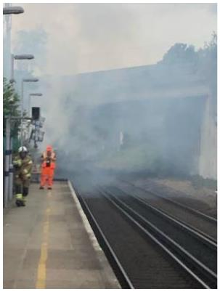
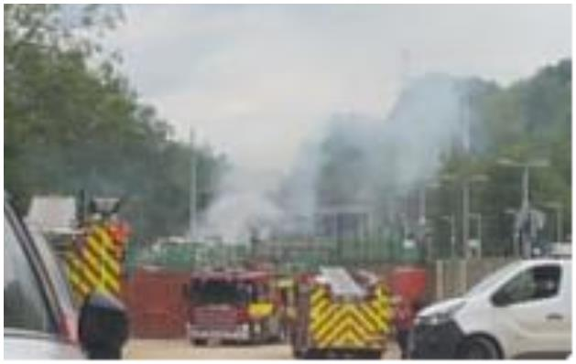
23 FIRES
Southern (Kent) – CCIL 1976919
At 1340, the driver of 1H86, Southeastern, 1231 Hastings – London Charing Cross, reported a fire in a
yard at Knockholt, outside the railway boundary. Trains were cautioned as a result, with the driver of a
subsequent train reporting that the smoke was becoming thicker and moving across the line. The driver of
2W40, Southeastern, 1219 Ramsgate – London Victoria then reported that the smoke was too thick for
trains to pass and both lines were blocked between Sevenoaks and Orpington. A replacement bus service
was implemented between the two locations, calling at all stations. The Fire Service were on site by 1407
and investigating the possible presence of acetylene cylinders. A Mobile Operations Manager arrived on
site at 1428 and confirmed that a portacabin, two lorries and several skips were on fire but no cylinders
had been located. An emergency switch-off of the traction current on both lines between Dunton Green
and Chelsfield was effected at 1450. By 1537, the fire had been extinguished and all personnel were clear
of the line. After the traction current had been recharged, normal signalling was able to resume from 1540.
TRUST 130883 XQMD
Cancelled 7 Part Cancelled 16 Trains Delayed 86 Minutes 1189
8

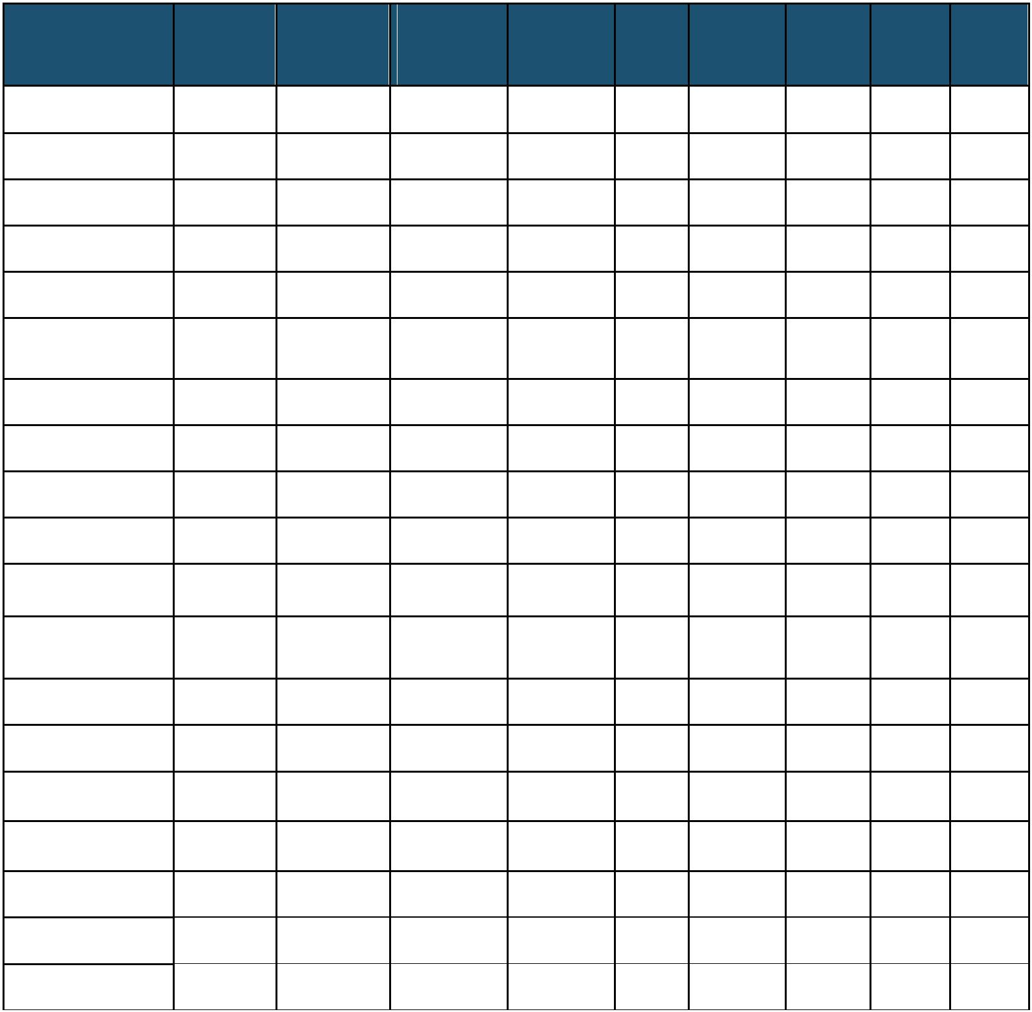
24 WILD REPORTS & HABD ACTIVATIONS
None.
 |  |  |  |  |  | Route Location Line |  |  |  |  |  |  |  |  |  |  |  |  |  |  |  |  |  |  |  | Date  Disconnected Reason |  |  |  |  |  | TOC’s/  FOC’s  advised |  |  |  |  |  | Planned  Restoration  Date |  |  |  |  |  |  |  |  |  | Date  Restored Function |  |  |  |  |  |  |  |  |  | Fault  Number
 |  |  | Eastern (Anglia) Brentwood Down Electric 10/03/16 Offline Y Awaiting  update |  |  |  |  |  |  |  |  |  |  |  |  |  |  |  |  |  |  |  |  |  |  |  |  |  |  |  |  |  |  |  |  |  |  |  |  |  |  |  |  |  |  |  |  |  |  |  | IM 234632
 |  |  | Eastern (Anglia) Brentwood Down Main 10/03/16 Offline Y Awaiting  update |  |  |  |  |  |  |  |  |  |  |  |  |  |  |  |  |  |  |  |  |  |  |  |  |  |  |  |  |  |  |  |  |  |  |  |  |  |  |  |  |  |  |  |  |  |  |  | IM 234632
 |  |  |  |  | Eastern (EM) |  |  |  |  |  |  | Barrow on  Soar Down Fast 14/05/19 Defective Y |  |  |  |  |  |  |  |  |  |  |  |  |  |  |  |  |  |  |  |  |  |  |  |  |  |  |  |  |  |  | Awaiting  update 147039
 |  |  |  |  | Eastern (EM) Barrow on  Soar |  |  |  |  |  |  |  |  |  |  |  |  |  |  |  |  |  |  | Down Slow 14/05/19 Defective Y Awaiting  update |  |  |  |  |  |  |  |  |  |  |  |  |  |  |  |  |  |  |  |  |  |  |  |  |  |  |  |  |  |  |  |  |  |  | 147040
 |  |  |  |  | Eastern (EM) Langley Mill |  |  |  |  |  |  |  |  |  |  |  |  |  |  |  |  | Up Erewash  Fast 14/05/19 Defective Y |  |  |  |  |  |  |  |  |  |  |  |  |  |  |  |  |  |  |  | Awaiting  update 147041
 |  |  |  |  | Eastern (EM) Willington Down Main 03/07/19 Offline Y Awaiting  update |  |  |  |  |  |  |  |  |  |  |  |  |  |  |  |  |  |  |  |  |  |  |  |  |  |  |  |  |  |  |  |  |  |  |  |  |  |  |  |  |  |  |  |  |  |  |  |  |  |  |  |  |  | 148316
 |  |  |  | Eastern (LNE) Barkston Up Main 01/04/19 |  |  |  |  |  |  |  |  |  |  |  |  |  |  |  |  |  |  |  |  |  |  |  | Removed for  P’Way work Y |  |  |  |  |  |  |  |  |  |  |  |  |  |  | Awaiting  update
 | North West & Central  (LNWN) |  |  |  |  |  |  |  |  |  |  |  |  |  |  |  |  |  | Low Mill Down Main 26/11/14 Awaiting  replacement |  |  |  |  |  |  |  |  |  |  |  |  |  |  |  | Y Awaiting  update |  |  |  |  |  |  |  |  |  |  |  |  |  |  |  |  | IP 671852
 | North West & Central  (LNWN) Coppull Down Main 08/02/19 HOBC work Y |  |  |  |  |  |  |  |  |  |  |  |  |  |  |  |  |  |  |  |  |  |  |  |  |  |  |  |  |  |  |  |  |  |  |  |  |  |  |  |  |  | Awaiting  update IP
 | North West & Central  (LNWN) |  |  |  |  |  |  |  |  |  |  |  |  |  |  |  |  |  |  | Coppull Up Main 08/02/19 HOBC work Y Awaiting  update |  |  |  |  |  |  |  |  |  |  |  |  |  |  |  |  |  |  |  |  |  |  |  |  |  |  |  |  |  |  |  | IP
 | North West & Central  (LNWS) |  |  |  |  |  |  | Castlethorpe Up Fast 27/11/18 Error code  6.0 |  |  |  |  |  |  |  |  |  |  |  |  |  |  |  |  |  |  |  |  |  |  |  |  |  |  | Y |  |  |  |  |  |  |  | Awaiting  Update |  |  |  |  |  |  |  | IM 832410
 | North West & Central  (LNWS) Harecastle Up Main 01/04/19 |  |  |  |  |  |  |  |  |  |  |  |  |  |  |  |  |  |  |  |  |  |  |  |  |  |  |  |  | Rail  incorrectly  drilled |  |  |  |  |  | Y |  |  |  |  |  |  |  | Awaiting  Update
 | North West & Central  (LNWS) Shallowford Up Slow 30/05/19 Defective Y |  |  |  |  |  |  |  |  |  |  |  |  |  |  |  |  |  |  |  |  |  |  |  |  |  |  |  |  |  |  |  |  |  |  |  |  |  |  |  |  |  | Awaiting  Update IM 852505
 |  | Wales & Western  (Western) |  |  |  |  |  |  |  |  | Keinton  Mandeville |  |  |  |  |  |  |  |  |  |  | Up Athelney 20/06/19 Defective Y Awaiting  Update |  |  |  |  |  |  |  |  |  |  |  |  |  |  |  |  |  |  |  |  |  |  |  |  |  |  |  |  |  |  |  |  |  |  |  |  | 442419
 |  | Wales & Western  (Western) |  |  |  |  |  |  |  |  |  |  |  |  |  |  |  | Keyham Up Main 05/07/19 Defective Y Awaiting  Update |  |  |  |  |  |  |  |  |  |  |  |  |  |  |  |  |  |  |  |  |  |  |  |  |  |  |  |  |  |  |  |  |  |  |  |  |  |  |  |  |  | 443873
 |  | Wales & Western  (Western) Maidenhead Up Main 01/04/19 No dial-up Y |  |  |  |  |  |  |  |  |  |  |  |  |  |  |  |  |  |  |  |  |  |  |  |  |  |  |  |  |  |  |  |  |  |  |  |  |  |  |  |  | Awaiting  Update
 |  | Wales & Western  (Western) Treverrin Up Main 01/07/19 Y |  |  |  |  |  |  |  |  |  |  |  |  |  |  |  |  |  |  |  |  |  |  |  |  |  |  |  |  |  |  |  |  |  |  |  |  |  |  |  |  | Awaiting  Update 443462
 |  | Wales & Western  (Western) |  |  |  |  |  |  |  |  |  |  |  | Treverrin Down Main 01/07/19 Y Awaiting  Update |  |  |  |  |  |  |  |  |  |  |  |  |  |  |  |  |  |  |  |  |  |  |  |  |  |  |  |  |  |  |  |  |  |  |  |  |  |  |  |  |  |  |  |  |  | 443474
 |  | Wales & Western  (Western) Urchfont Up Westbury 31/05/19 Defective Y |  |  |  |  |  |  |  |  |  |  |  |  |  |  |  |  |  |  |  |  |  |  |  |  |  |  |  |  |  |  |  |  |  |  |  |  |  |  |  |  | Awaiting  Update IM
25 GROUP STANDARDS GE/RT8250 & GO/RT3350
None.
26 MISCELLANEOUS
None.
9


27 REVIEW TABLE
 |  |  |  |  | INCIDENT TODAY’S TOTAL |  |  |  | DAYS SINCE LAST  INCIDENT
 |  | PASSENGER ACCIDENTAL  FATALITIES |  |  |  |  | 0 214
 |  |  |  | RAILWAY WORKFORCE  FATALITIES |  |  | 0 3
 |  |  | SIGNALS PASSED AT RED  (CATEGORY ‘A’) |  |  |  | 2 0
 | SIGNALS PASSED AT DANGER  (ERROR/TECHNICAL SIGNAL  REVERSION) |  |  |  |  |  | 2 0
DERAILMENTS 0 15
TRAIN COLLISIONS 0 10
 | TRAINS STRIKING ROAD  VEHICLES |  | 0 57
ENVIRONMENTAL INCIDENTS 0 37
10

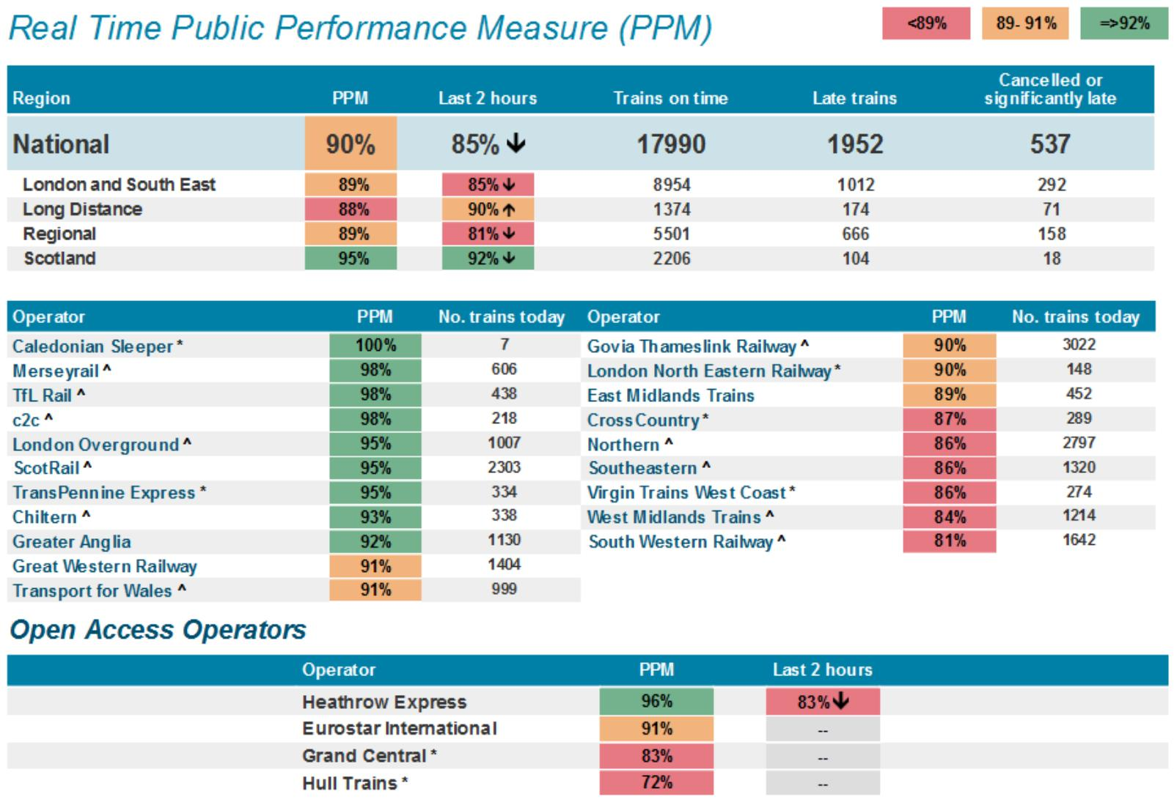
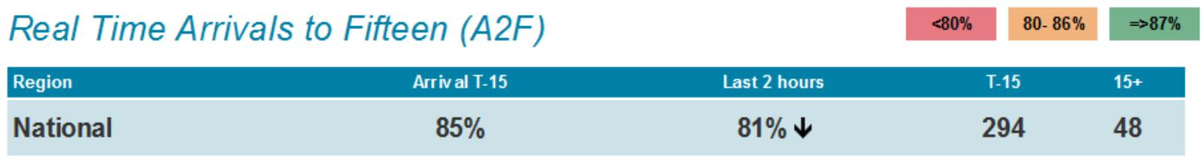
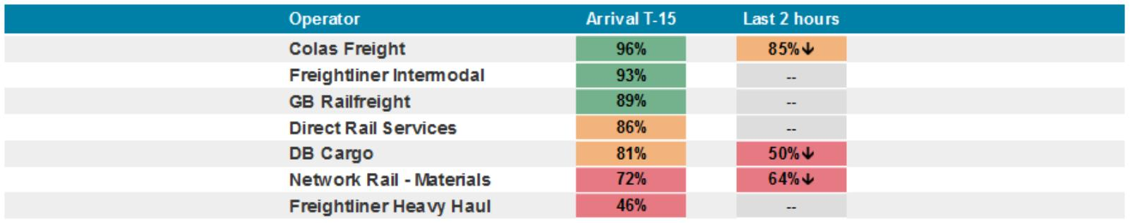
28 REAL TIME PERFORMANCE FIGURES
11

